Mesh Tools
A Mesh Toolbox for Unity

To open the Mesh Tools window click on the Window menu item in Unity, hover the mouse over the Mesh Tools item and then click on Open Window.

The Mesh Tools window is tabbed so you can dock the window by clicking on its tab and dragging it next to your other windows. The Mesh Tools window has a vertical style so I suggest you dock the window to the left of your Hierarchy view.

If you need to get back to this tutorial while in Unity you can click on the help button at the top right of the Mesh Tools window and this page will open up in your browser.
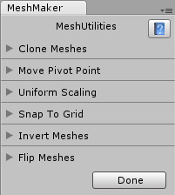
Currently there are eight utilities and they all work on one or more game objects. So you generally begin by selecting the game objects in your scene that you would like to work on.

To select multiple objects you can click and drag a rectangle around them in the Sceneview window or by holding the CTRL key down on the keyboard while clicking on each one in the Sceneview window.

All of these utilities will work on one or more objects if selected. If you want undo any operation you will have to perform the opposite of that operation.

To view and begin using each utility start by clicking on the small triangle to the left of the utility name and the foldout will open up.

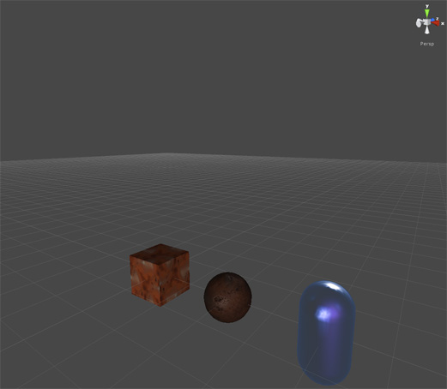
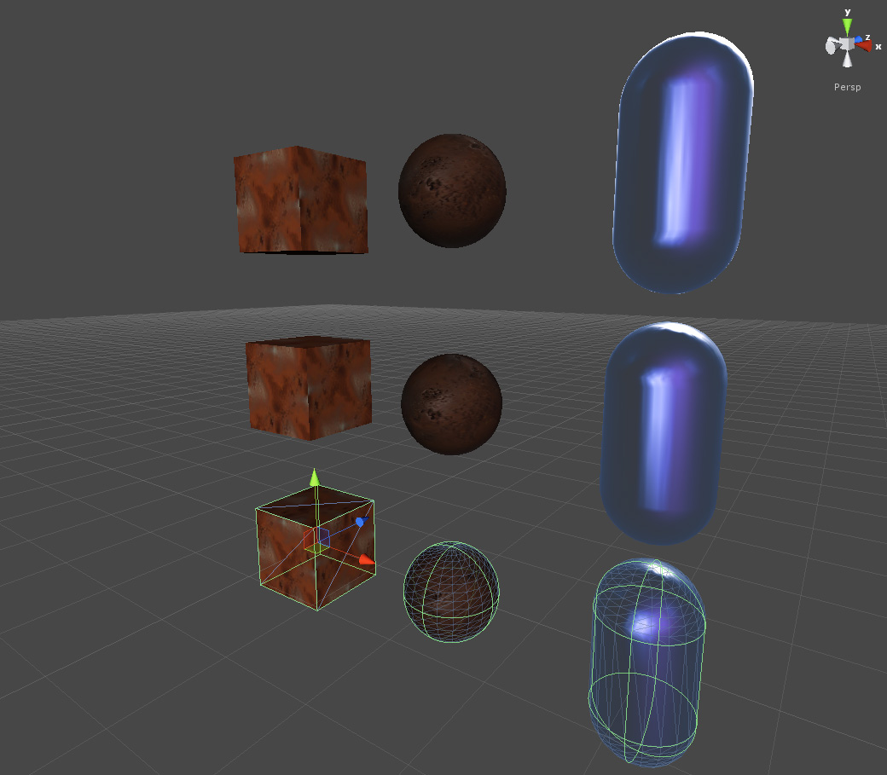
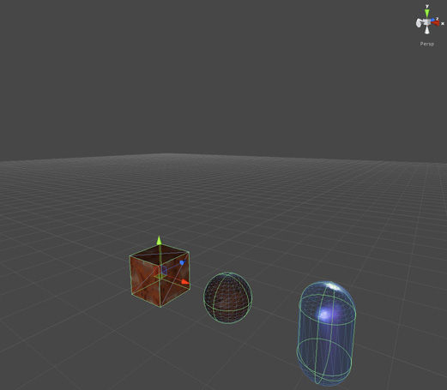
Clone Meshes

By default when you click on the Apply button without changing any settings then this utility will simply copy the object once and place it in the same position as the original object similar to using CTRL-C and CTRL-V.
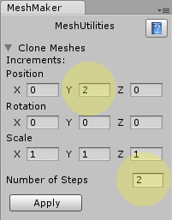

This utility allows you to change the position, rotation and scale of the cloned objects before creating them. You can also change the Number of Steps which means the number of repetitions of the clone operation.

The images to the right show the result of selecting three objects, changing the Y position to 2 and the number of steps to 2 and then clicking on the Apply button.

Move Pivot Point

When a model such as a cube is created through Unity or a model is imported from a 3rd party application the pivot point is preset. This utility allows you to move and rotate that pivot point. The coordinates when changing the position of a pivot point are in world space coordinates so if an object is rotated then the Y orientation is still vertical from the original pivot point.

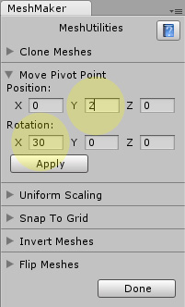
The following image shows an object with a pivot point that has been moved 2 units in the Y axis and rotated by 30 degrees after clicking on Apply.

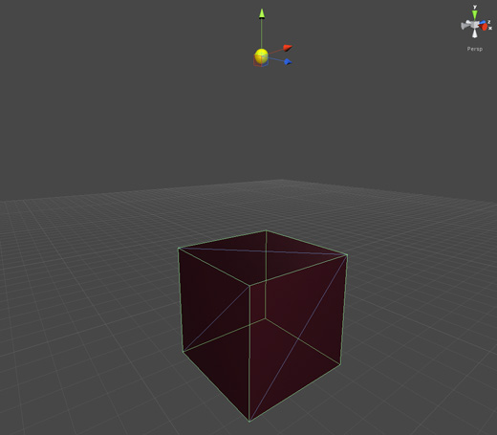

Uniform Scaling

The uniform scaling utility is a time saver that allows you to scale an object in more than one dimension at a time. Select the dimensions you want to scale by clicking on the toggle boxes and then drag the slider left and right to change the scale of the object from 0.01 and 100. This works well while also using the Snap to Grid utility which I will cover next.

The following image shows a cube that has been flattened in the Y axis and then scaled uniformly in the X and Z axes.

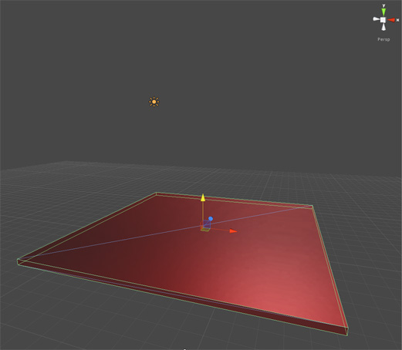

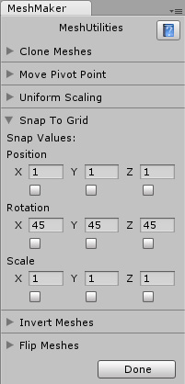
Snap To Grid

The snap to grid utility is a must have tool when setting out the positions of your objects in the scene. This tool allows you to not only snap to a certain position on a grid but you can also snap to a certain rotation angle or snap to a certain scale value. You can selectively choose which axis to apply the snap values to or select all three at once.

To do this enter the values for the position, rotation or scale that you want your object to move by and then click on the toggle switches below those values. You will notice that when you move the object in the Sceneview window or change its transform values in the inspector that the objects will jump to the closest position that fits your snap values.

Invert Meshes

To invert an existing model or multiple models inside out first select the object and then click on the Apply button. The image below shows a cube on that has been turned inside out.

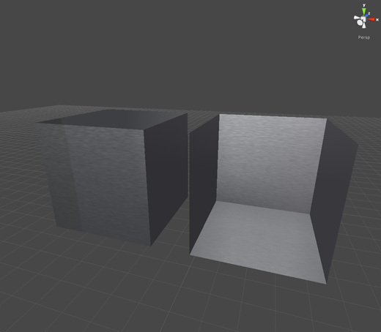
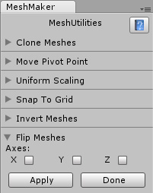

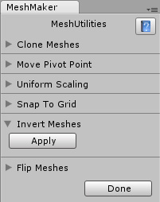
Flip Meshes

Flip meshes allows you to create a mirror image of a model. You would use this if you wanted matching book ends for example. To flip a mesh you would first duplicate the existing object and then select the new copy in the Sceneview window before ticking the X axis toggle switch and then clicking on the Apply button.

All of these utilities work on meshes with multiple materials and the submeshes of an object.

Split Mesh
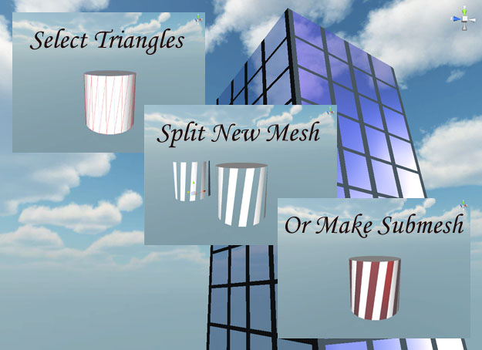
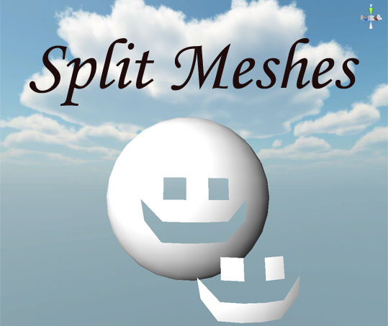
To begin splitting a mesh start by selecting a game object and ensuring it has a collider of type Mesh Collider. Then hold down the left Alt key while left clicking on the triangles of the mesh to select them. Left clicking on a selected triangle will deselect that triangle or you can click on the Clear button in the MeshPainter window to deselect all of the selected triangles.

To create a new mesh or submesh from the selected triangles right click while holding down the left Alt key. This will create a new mesh and set it as a child object of the selected object. If the box labeled Create Submesh is checked then the selected triangles will remain a part of the original mesh.
You can apply a new material to the child object in the hierarchy or to the submesh through the materials list of the Mesh Renderer in the inspector.

After splitting a mesh or after making changes to the textures of a mesh you can click on the Reset button to undo those changes. If you click on another object in the scene then the changes become permanent and cannot be undone.

An interesting side benefit to this undo feature is that if you click on the Reset button after the split then the original mesh will be restored and you will still have the newly created child mesh in your hierarchy.

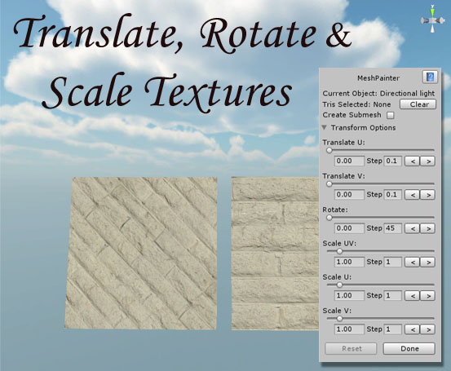
Transform Textures

You can also select groups of triangles to transform the textures directly on the mesh. The Transform Options in the Mesh Tools window can translate, rotate and scale the textures easily by using the sliders or by entering a value into the text fields for each transform. The left and right buttons for each transform will move, rotate or scale the textures by the given step amount.

Real Scale

Change the local scale of an object without changing its scale in Unity. Select an object, enter new values for the objects X, Y and Z scale and hit apply. The scale shown in the inspector will remain unchanged.

Double Sided Meshes

Change single sided meshes to double sided. Reveal the inside of houses, cars, anything. Select an object with a single sided mesh and click the Apply button to perform the operation.

Save Mesh

Create a mesh file from the currently selected object. Enter a new name for the mesh file and click on the Save Mesh button. The file will be added to the Meshes folder within the main folder.

To learn more about Mesh Tools and to view the tutorial videos you can visit
MeshMaker.com

